**How to host static pages of your project in GitHub**

1. Create a new empty repository in your GitHub with your GitHub username.

Username.github.io

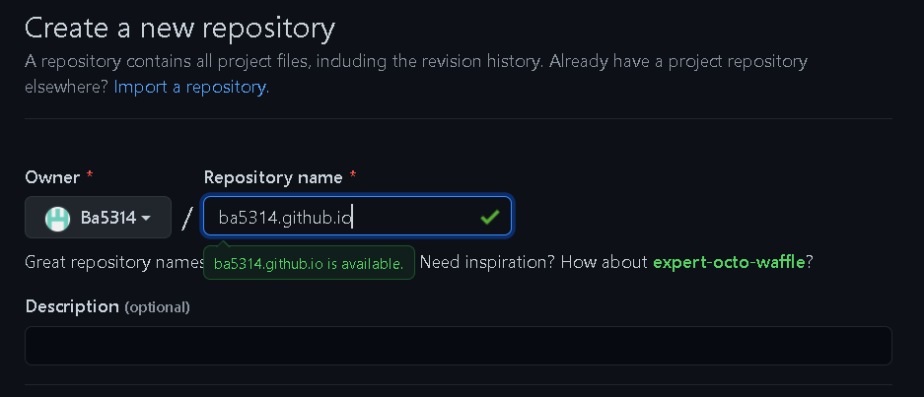

1. Copy the https link of your repository.



1. Go to your konfinity repository main folder in your vs code terminal.

Enter the command “ls -a” to view the hidden directory “.git”.

Go to the “.git” directory with “cd .git” command.

And open config file with “vi config” command

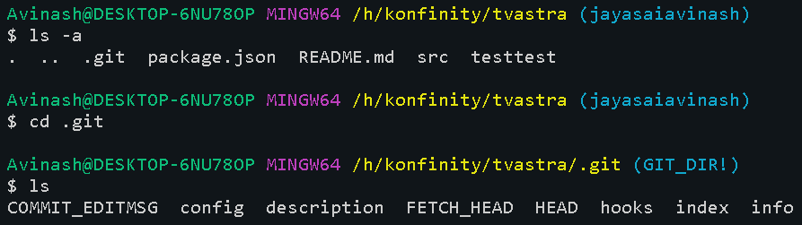



1. Find the [remote origin] section in the config file.

Press “ I “ to insert text.

1. You will have one URL of your konfinty repository add another URL of your GitHub repository.

URL = your GitHub https URL

1. After typing the URL press esc then :wq to save and exit the file
2. Push your code normally how you push your code to konfinity repository. The code will be pushed to your two repositories (GitLab and GitHub.
3. It will ask you to authorize your GitHub account authorize it.
4. Push your code normally how you push your code to konfinity repository. The code will be pushed to your two repositories (GitLab and GitHub)
5. Now go to browser and type your GitHub repository name “username.github.io/your file path”.

It will open your static page.